HACKANOVA 2026 – PARTICIPANT CONSENT LETTER & UNDERTAKING

I, PRAGATI SHARMA , a participant of HACKANOVA 2026, hereby declare that:
- I have read and understood all the instructions, rules, and guidelines of the hackathon.
- I voluntarily agree to participate in the 36-hour on-campus hackathon conducted by BVDU DMS.
- I consent to stay on campus for the entire duration of the event.
- I agree to follow the code of conduct, safety instructions, and discipline norms.
- I understand that the organisers are not responsible for loss of personal belongings.
- I grant permission to the organisers to use photographs/videos taken during the event for academic and promotional purposes.
- I shall be solely responsible for any violation of rules or misconduct.
I affirm that the above information is true and I accept all terms and conditions of participation.
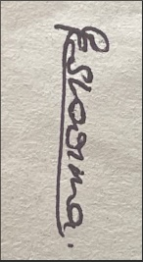
Participant Name: , PRAGATI SHARMA
Team Name / ID: SILENT CODERS /AT109
Signature: ___________________________
Date: December 26 , 2025

By Order of:
HACKANOVA 2026 Organising Committee
Department of Management Studies, BVDU

